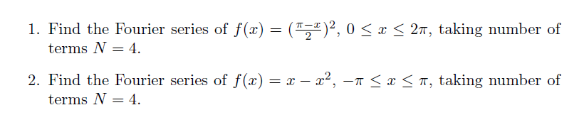

**ARYAMAN MISHRA**

**19BCE1027**

**CODE:**

syms x

f=input('Enter the function in terms of x:')

L=input('Enter the lower limit of the domain')

U=input('Enter the upper limit of the domain') % (L,U)

L1=(U-L)/2;

disp('Enter value of N between 1 and 7')

N=input('Enter the number of terms N')

a_0=vpa((2/(U-L))*int(f,x,L,U),4); %

F_s=a_0/2;

for n=1:1:N

a(n)=vpa((2/(U-L))*int(f*cos((n*pi*x)/L1),x,L,U),4); %2/(U-L)=1/L1

b(n)=vpa((2/(U-L))*int(f*sin((n*pi*x)/L1),x,L,U),4);

F_s=F_s+a(n)*cos((n*pi*x)/L1)+b(n)*sin((n*pi*x)/L1) % F_s= a0/2+a1+b1 ; 2nd iteration: F_s= a0+a1+b1+a2+b2

subplot(N,1,n)

plot1=ezplot(f,[L,U]);

set(plot1,'color','r')

hold on

ezplot(F_s,[L,U])

end

1. >> fourier

Enter the function in terms of x:((pi-x)/2)^2

f =

(x/2 - pi/2)^2

Enter the lower limit of the domain0

L =

0

Enter the upper limit of the domain2*pi

U =

6.2832

Enter value of N between 1 and 7

Enter the number of terms N4

N =

4

F_s =

1.0*cos(x) + 0.82246703342752880416810512542725

F_s =

0.25*cos(2*x) + 1.0*cos(x) + 0.82246703342752880416810512542725

F_s =

0.25*cos(2*x) + 0.11111111111131322104483842849731*cos(3*x) + 1.0*cos(x) + 0.82246703342752880416810512542725

F_s =

0.25*cos(2*x) + 0.11111111111131322104483842849731*cos(3*x) + 0.0625*cos(4*x) + 1.0*cos(x) + 0.82246703342752880416810512542725

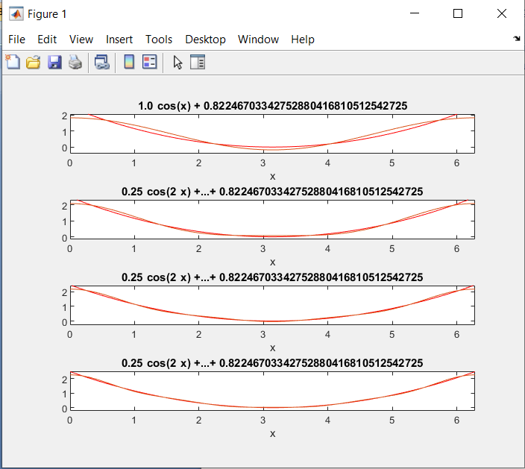

2) >> fourier

Enter the function in terms of x:x-(x^2)

f =

- x^2 + x

Enter the lower limit of the domain-pi

L =

-3.1416

Enter the upper limit of the domainpi

U =

3.1416

Enter value of N between 1 and 7

Enter the number of terms N4

N =

4

F_s =

4.0*cos(x) + 2.0*sin(x) - 3.289868133710115216672420501709

F_s =

4.0*cos(x) - 1.0*sin(2*x) - 1.0*cos(2*x) + 2.0*sin(x) - 3.289868133710115216672420501709

F_s =

0.44444444444525288417935371398926*cos(3*x) - 1.0*cos(2*x) - 1.0*sin(2*x) + 0.66666666666787932626903057098389*sin(3*x) + 4.0*cos(x) + 2.0*sin(x) - 3.289868133710115216672420501709

F_s =

0.44444444444525288417935371398926*cos(3*x) - 1.0*cos(2*x) - 0.25*cos(4*x) - 1.0*sin(2*x) + 0.66666666666787932626903057098389*sin(3*x) - 0.5*sin(4*x) + 4.0*cos(x) + 2.0*sin(x) - 3.289868133710115216672420501709

>>